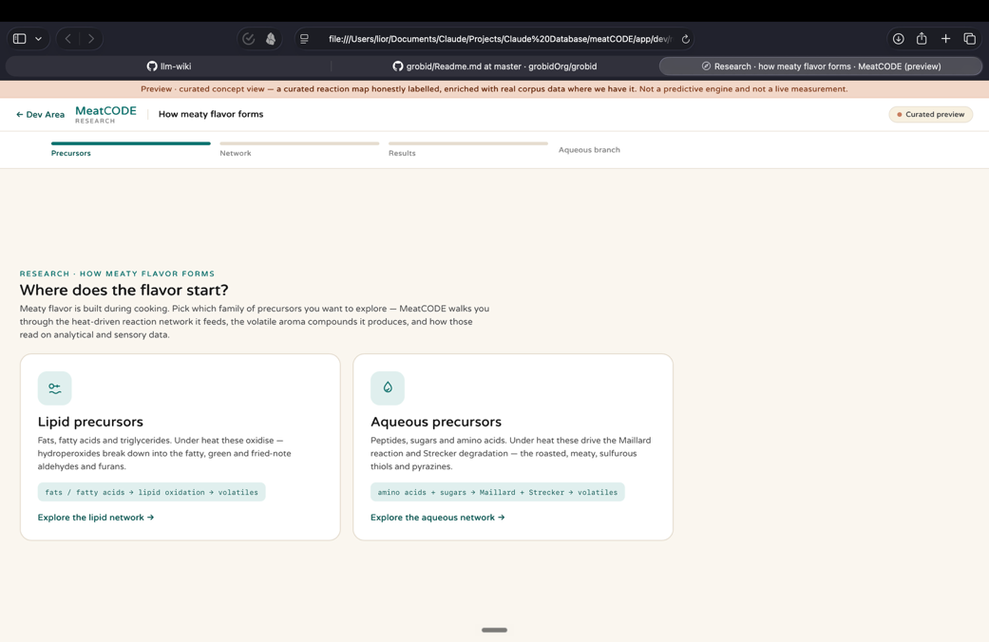
Make sure that the progress bar is centered in this upper middle part
Remove this blank space

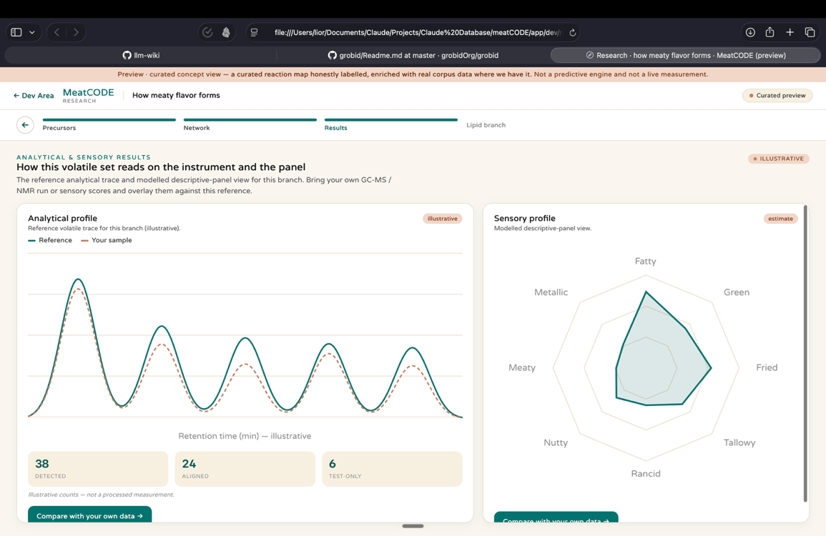
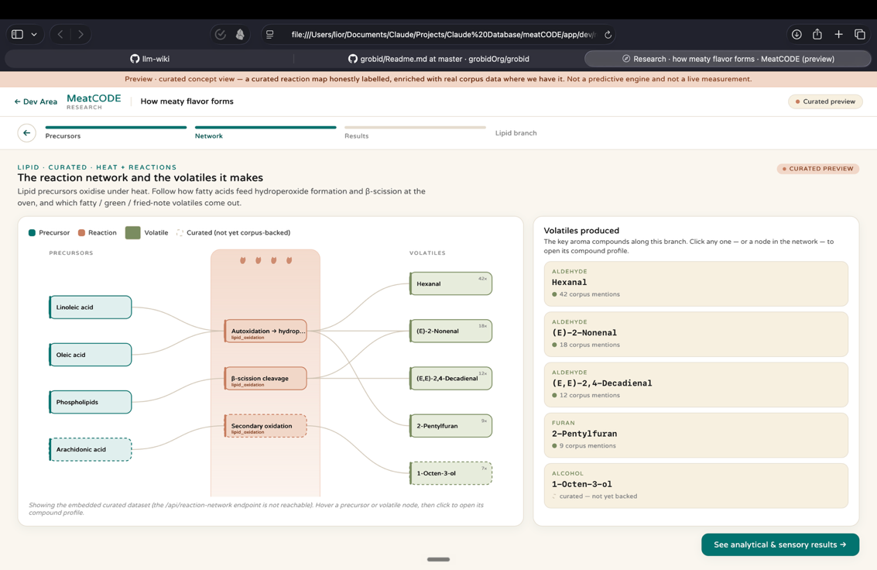
Regarding both of the profiles, I don’t want them to be scrollable – meaning that they should be fixed and static graphs. Make them fit to the screen
Regarding all of the objects in this network diagram No need to fully color the buttons, keep them light, on hover they can get color
No need for this section, it’s enough to keep the reaction network hoverable and clickable
Remove these descriptions, focus on minimalistic tags

